## 

## **Practical-3**

**Student Name:** Gauri Prabhakar **UID:** 18BCS6201

**Branch:** 18AITAIML-2 **Section/Group:** B

**Semester:** 7 **Date of Performance:** 9th September, 2021

**Subject Name:** Computer Vision Lab **Subject Code:** CSF - 432

# Aim/Overview of the practical:

To extract a warp perspective of a sub image from a larger image and then stack input and output images using python and OpenCV.

# Task to be done:

To extract a warp perspective of a sub image from a larger image and then stack input and output images using python and OpenCV and the explanation.

# Steps to be followed:

1. Importing necessary modules.
2. Creating a variable to store the image using the '.imread()' function.Creating a variable to store the image using the '.imread()' function.
3. Storing the height and width of the image.
4. The co-ordinates of the 3-D sub-image.
5. Using '.float32' to convert to decimal values.
6. Defining Old position of the sub-image.
7. Defining New position of the sub-image.
8. Transforming the perspective using the 'getPerspectiveTransform()' function.
9. Getting the Warp Perspective of the image using the 'warpPerspective()' function.
10. Returning the original image.
11. Returning the sub-image.
12. Setting up '.waitkey()' to wait for a specific time until any key is pressed.
13. Destroying all windows.
14. Defining the function 'stackImages()' to stack input images.
15. Using 'len()' to return the number of items in the 'imgArray' object which is used to store 1-D and 2-D images as an array.
16. Returning the number of rows.
17. Returning the number of columns.
18. Returning the image array in literal format.
19. Checking if we have a multilayer image.
20. The 'isinstance()' function returns true or false.
21. It takes the the columns and the list as an argument.
22. Storing the width and height of the image array.
23. Returning the width and height of the image array.
24. If 'rowsAvailable' evaluates to True:
25. Horizontally stacking the image.
26. Vertically stacking the image.
27. If 'rowsAvailable' evaluates to False:
28. Horizontally stacking the image.
29. Vertically stacking the image.
30. Writing driver code to trigger the stacks.
31. Creating a variable to store the image using the '.imread()' function.
32. Creating a variable to store the grayscale image using the function '.cvtColor()'.
33. Calling the ‘stackImages’ function.
34. Horizontally stacking the image.
35. Vertically stacking the image.
36. Returning the horizontally, vertically and stacked images.
37. Setting up '.waitkey()' to wait for a specific time until any key is pressed.
38. Destroying all windows.
39. **Result/Output/Writing Summary:**

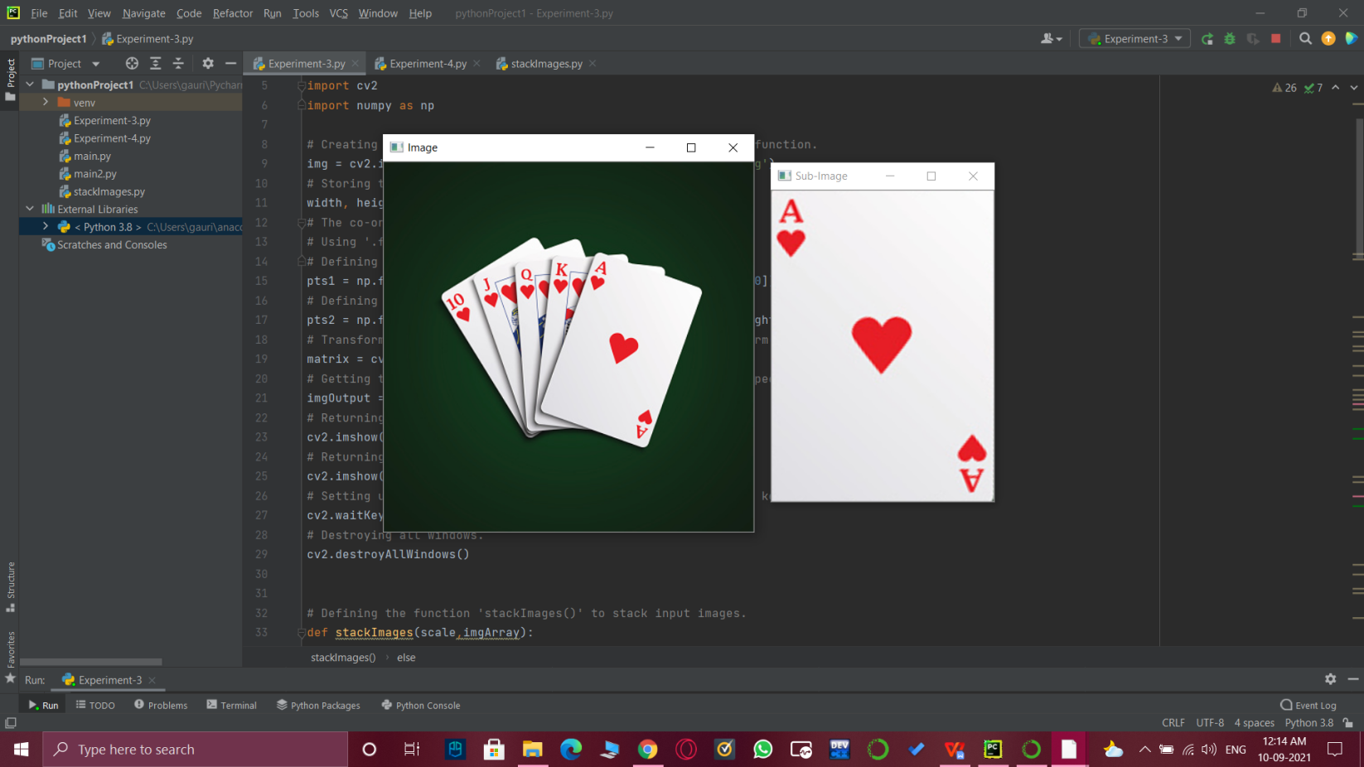

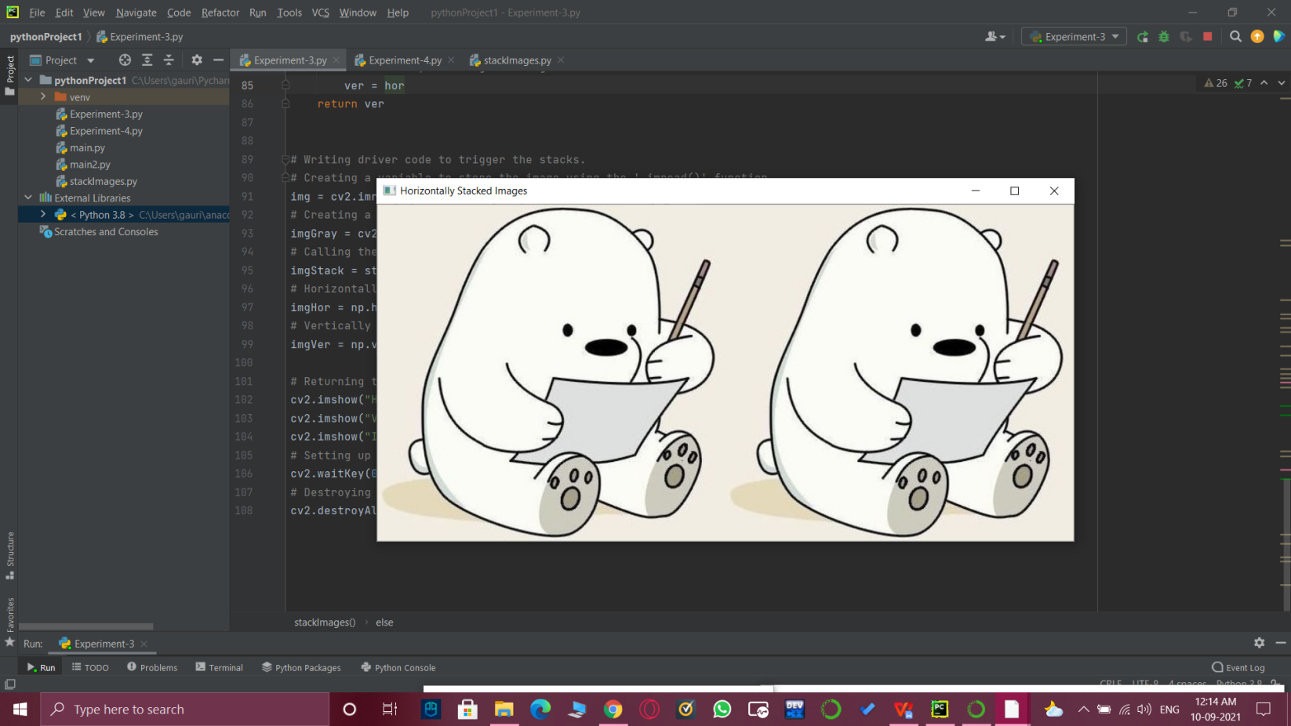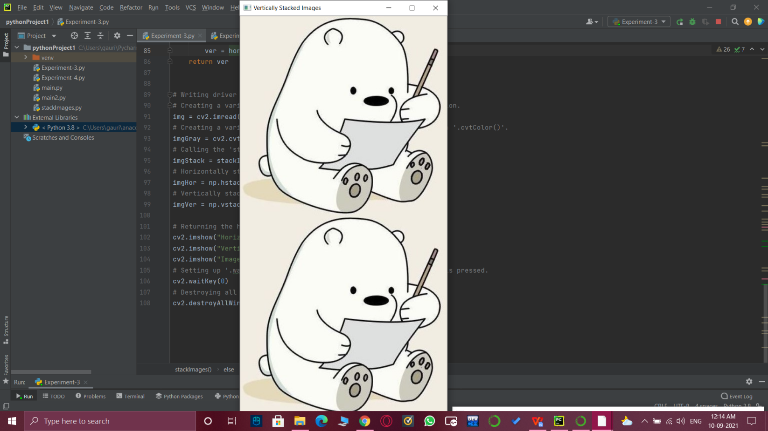

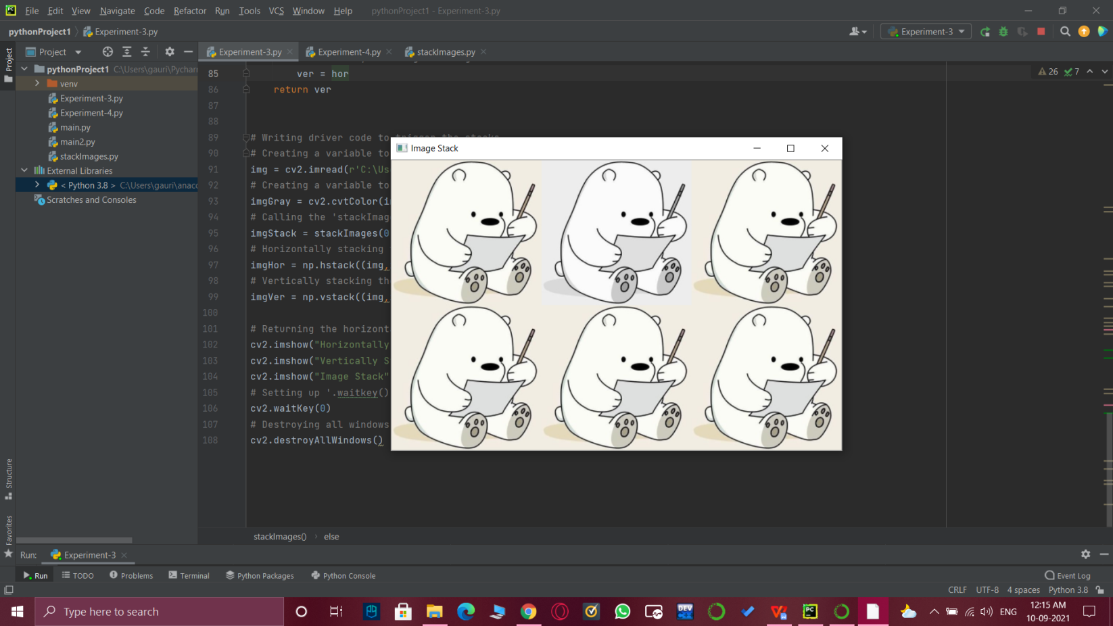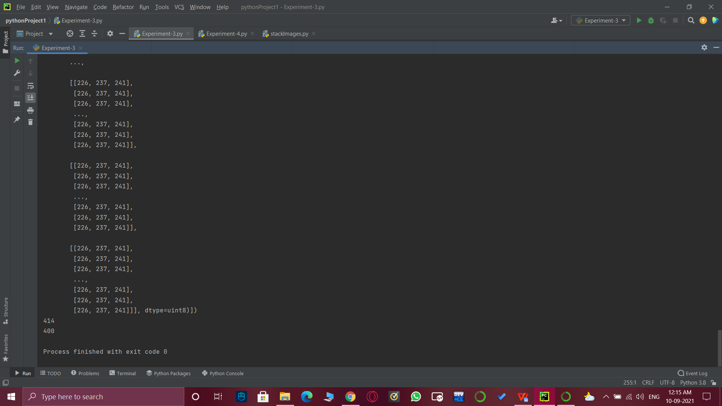

# Learning outcomes (What I have learnt):

* Open CV modules.
* Grayscale images.
* Warp Perspective.
* How to stack images.
* Vertically, horizontally stacked images.

**Evaluation Grid (To be created as per the SOP and Assessment guidelines by the faculty):**

|  |  |  |  |
| --- | --- | --- | --- |
| Sr. No. | Parameters | Marks Obtained | Maximum Marks |
| 1. |  |  |  |
| 2. |  |  |  |
| 3. |  |  |  |